# **GUI**

Figure Options/search

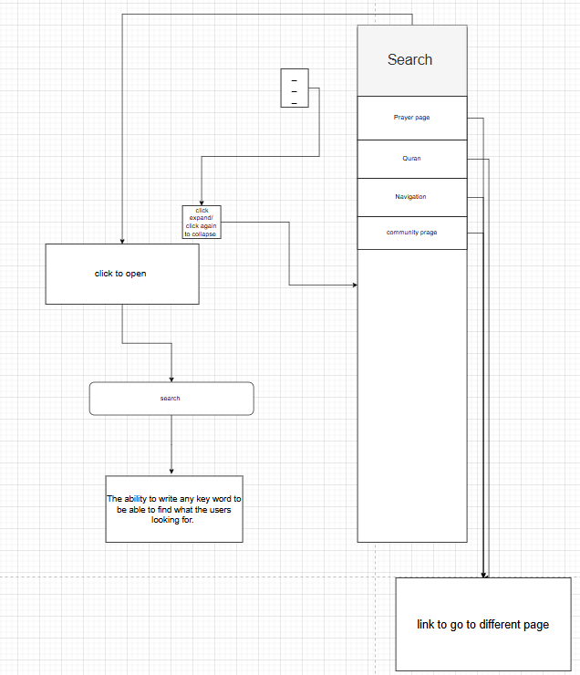I decided to create this search and navigation flow to make my app easier for users to interact with. The main reason for including a search bar is to allow users to quickly access specific content, such as prayer times, Quran references, or community features, without needing to scroll or click through multiple menus. This improves efficiency and reduces user frustration.

The expandable menu option (click to open/close) provides a clean and simple interface. This is important because people who want quick access to religious information on the go, for example during travel or at work. A collapsible menu avoids clutter while still keeping the most important pages accessible.

I also added the ability for users to type any keyword into the search function. This makes the app more flexible and user-friendly, as people may use different terms to find the same thing. For example, someone could search “Quran” or “Surah” and still find the relevant page. This reduces the chance of users feeling lost or unable to find what they are looking for.

Finally, I made sure each search result and menu item links directly to the relevant page. This ensures smooth navigation and helps the app feel more professional and reliable. By designing the flow this way, I focused on **usability (easy to use), accessibility (clear layout), and efficiency (fast navigation)**, which are all key design principles for apps.

Figure Homepage

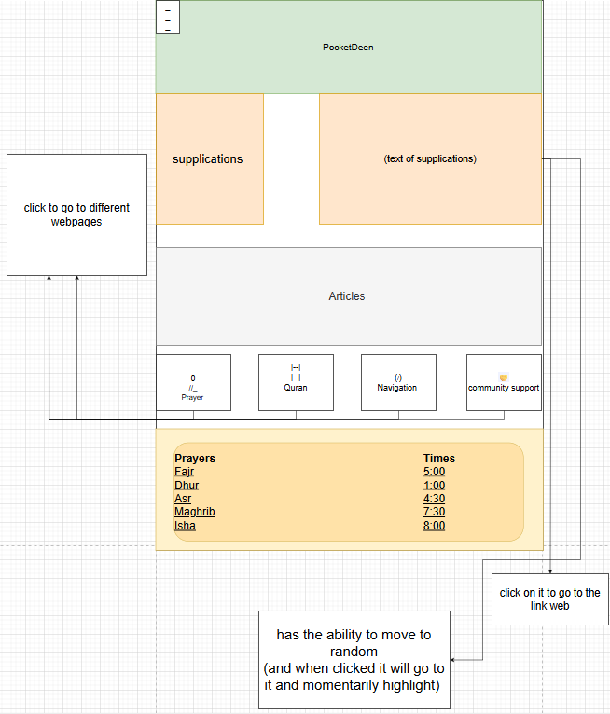

I made this design, so the Homepage is easy for people to use. I added things like supplications, Quran, articles, navigation, and community support because these are the main features users will need. I also put the prayer times at the bottom of the page. This is important because people check prayer times every day, so having them shown straight away saves time and makes the home more useful.

I also included features like being able to click to move to different pages or highlight links. This makes the app more interactive and stops it from feeling boring. The buttons at the bottom give clear ways to move around the app, but the random movement option adds something extra for users who like exploring. This means the app works well for different types of people while still being simple to follow.

Figure prayer page

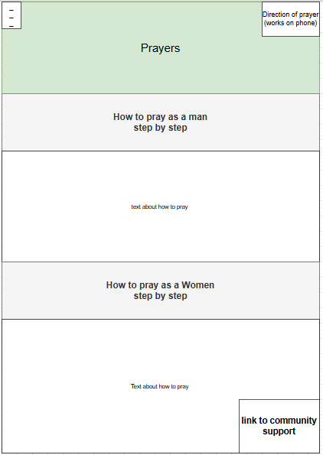

The prayer page is for people who want to learn how to pray in a clear and simple way. I decided to make it its own page so that everything about prayer is kept in one place and easy to find. This also helps the app look less crowded and more organized, which makes it easier for stakeholders and users to focus on what they need.

Figure Article

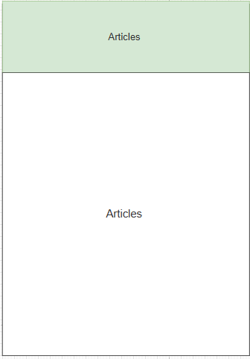

The articles page was made to give users extra information about Islamic topics. This is important because it allows people to learn more about their faith in their own time. By keeping all the articles on one page, it makes the app more organized and stops the other sections from feeling too crowded.

I also made this page so users can always come back and find useful information, like reminders, history, or advice. This means the app is not only about prayer times and the Quran but also about learning and personal growth. It gives stakeholders more value because the app supports both daily practice and long-term knowledge.

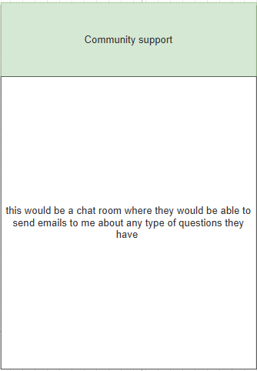

Theres nothing much to say about this page. I created this part of the website because users want to just ask any question they can, because with religion comes with a lot of questions that need to be answered, and I am not able to place every single detail on my website.

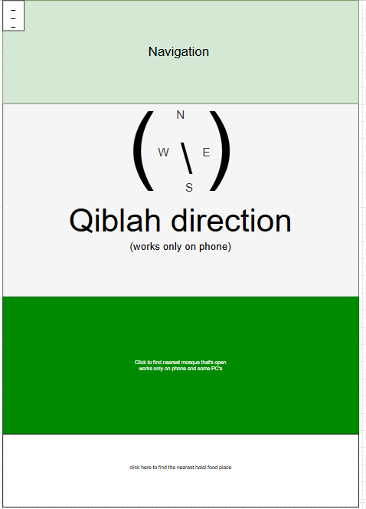

This page of my website is created to help people who want to be able find the nearest mosque and to find halal food to make them better in their faith. The compass to hajj (the pilgrimage) is created for people who want to pray at their homes or if they in an unfamiliar place to give them ease while trying to pray.

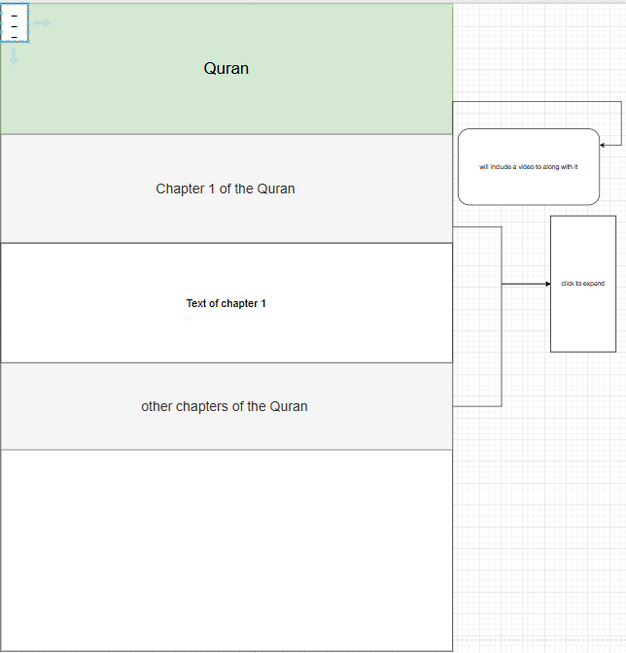

The Quran page is created to help people gain in knowledge of the Quran. I will split each chapter of the Quran and place them in a closable button so it's easier to read then 1 big chunk of text. On the top of each chapter will include a video link so the users can listen to how it sounds being read in Arabic.

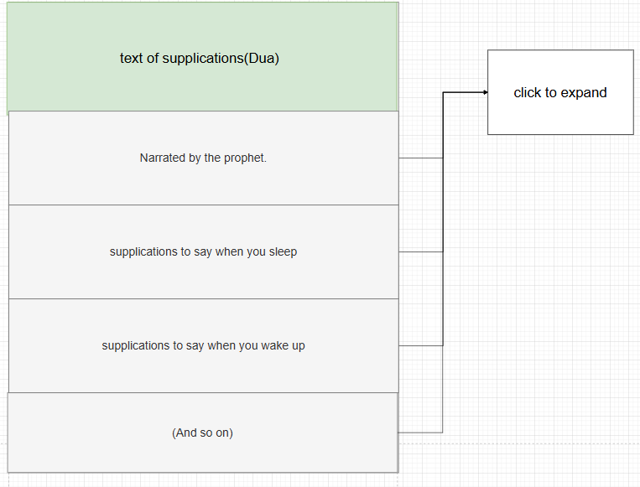

This page is for people who want to supplicate in the way the prophets may peace and blessings be upon them and there companions. This part of the website is the same as the quran the text would be able to collapse into a button and expand and i believe this would be useful for the stake holders.

# **Structure diagram**

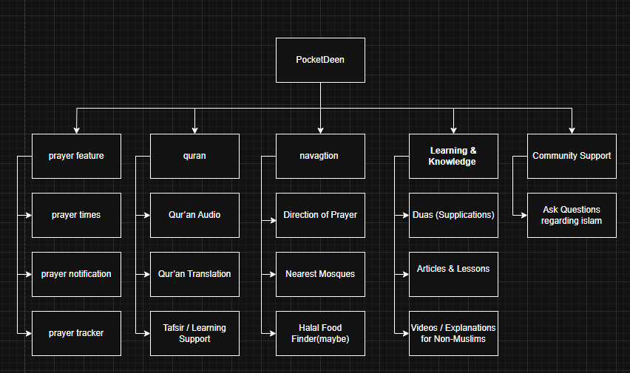

I created this structure diagram to organise my website and show how the features link together. The main section is PocketDeen, and from it I divided the site into prayer, Qur’an, navigation, learning, and community. Each part then has smaller features, like prayer times, Qur’an translation, or nearest mosques, so the layout is clear and easy to follow. I did this because it helps me plan the website better and makes it easier for users to find what they need.

# **Development plan**

**Stage Explanation**

In this stage, I will focus on building themain featuresof the website. These include the prayer page, Quran section, articles, navigation, and community support. I will also add a search bar so users can type keywords to quickly find information. Another feature will be the prayer times table, which shows the five daily prayers. This makes the app more useful and organized for the users.

For the structures, I will set up text files or arrays to store information such as prayer times, supplications, and articles. This will make it easier for the app to load and display content. Later, I could also use a database if I want the app to handle bigger amounts of data, like saving user questions in the community support section.

The algorithms I will use include searching through the data when users type in the search bar, highlighting links when clicked, and loading the correct page when a button is pressed. I will also use simple loops and conditions to check user input and display the right information. These algorithms will make the app interactive and responsive, so users can move around smoothly without confusion.

|  |  |  |  |  |  |  |
| --- | --- | --- | --- | --- | --- | --- |
| Test No. | Subroutines | Test description | Test data | Expected outcome | Actual outcome | Type of test |
| 1.Home page |  |  |  |  |  |  |
|  | supplications | Does the program display text and rotate to display different supplications | STR | The text displays and displays different texts | / | / |
|  | Articles | Displays important information about the world each day | str | Displays important information about the world each day | / | / |
|  | To click the different buttons | Being able to press on like the supplications and it takes you to the supplication page and if you press on a text, it would take you to that text | str | To click on a button and it takes you to a page. | / | / |
|  | Prayer times | Prayers that display the appropriate times to pray. | str |  | / | / |
| Hamburger menu |  |  |  |  | / | / |
|  | Prayer page | Users press to go to page | str | To click on a button and it takes you to a page. | / | / |
|  | Quran page | Users press to go to page | boll | To click on a button and it takes you to a page. | / | / |
|  | navigation | Users press to go to page | boll | To click on a button and it takes you to a page. | / | / |
|  | Community page | Users press to go to page |  | To click on a button and it takes you to a page. | / | / |
|  | Search bar key word | The ability to typer any key word like (Quran) and takes you to the page but also gives you suggestion like a surah in the Quran |  | To take the user to the page they have typed. | / | / |
|  | Search bar words | Write a series of words like (I want to learn the night supplications) |  | The ability to take the user to a specific area of the website by typing a series of words and highlight the text to help them find it | / | / |
|  | Hamburger menu | Expandable and collapsible. |  | When the users click on the Hamburger it will expand and when they click again it will collapse | / | / |
| How to Pray (prayer site) |  |  |  |  |  |  |
|  | How to pray as a man | The text that's displayed when the button (how to pray as a man) |  |  |  |  |
|  | How to pray as a women | The text that's displayed when the button (how to pray as a woman) |  |  |  |  |
| Navigation direction |  |  |  |  |  |  |
|  | Compass to hajj | the needle point to hajj |  | The needle will point in the direction to hajj for iPhone no matter where they are |  |  |
|  | Maps | The map will locate the nearest open mosque. |  | The map should locate the nearest mosque like in google maps. |  |  |
|  | Halal food places | Helps users find halal restraints. |  | The map should locate the nearest halal food places like in google maps. |  |  |
| Quran |  |  |  |  |  |  |
|  | Open and colipasel buttens for the quran | / |  | / | / | / |